Mission 1:

Starwars.com mail servers

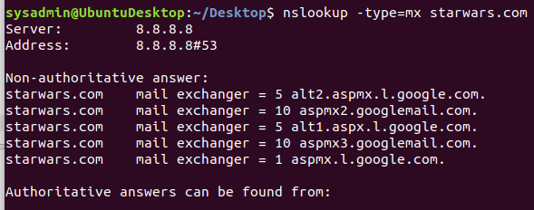

The resistance isnt receiving any emails because none of the DNS mail exchange servers have been changed to the new address.

In order to address this issue, the new primary server should replace aspmx.l.google.com as it has the highest priority, and the new secondary server can replace those with the next level priority of 5.

Missions 2:

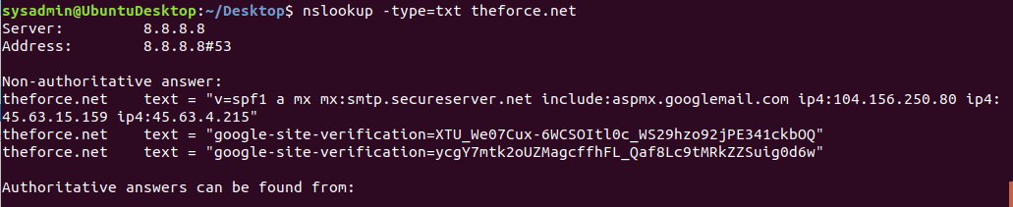

The Force’s emails are going to spam because the new email server IP is out of the specified ranges of ip allowed to be sent.

In order for emails from theforce.net to be sent they’ll have to extend the allowed range of ip addresses to include 45.23.176.21

Mission 3:

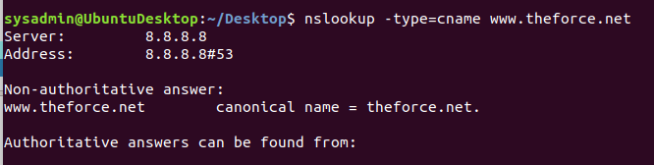

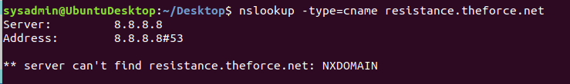

The subpage of resistance.theforce.net is not redirecting to theforce.net because there is no cname record which means it cannot be redirected to the same server. In order to fix it, they must ensure the cname record is updated for resistance.theforce.net

Mission 4:

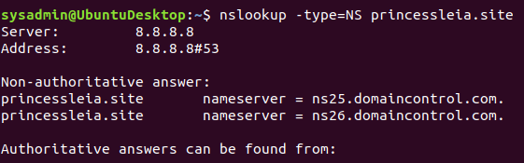

In order to prevent this attack from affecting the servers again, the current DNS servers will need to be updated and have a number of backup servers in the event of taking down a primary server. It will also be good to check that the DNS records are up to date.

Mission 5:

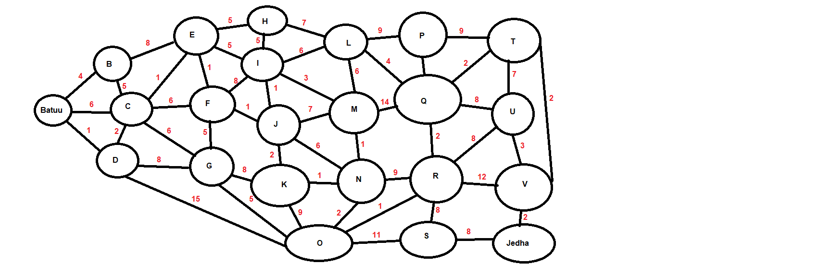

OSPF from Batuu To Jedha

Batuu > D > C > E > F > J > K > O > R > S > Jedha

Total time: 34

Mission 6:

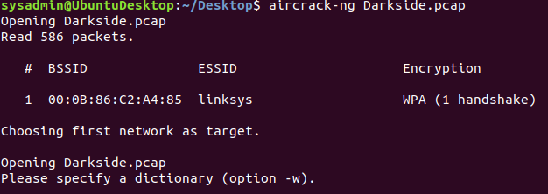

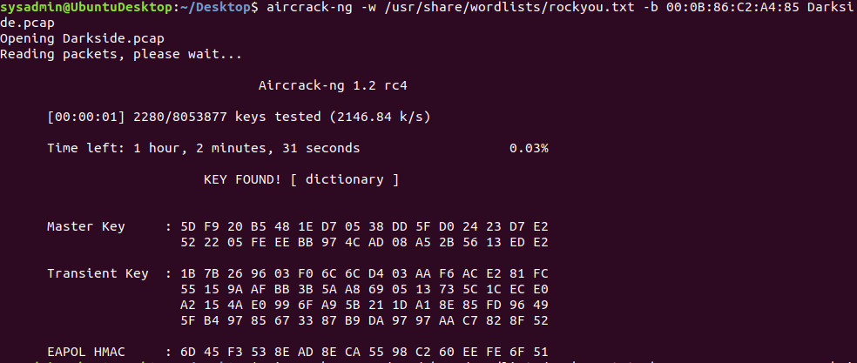

Looking through the decrypted ARP traffic in Darkside.pcap using the WPA key “dictionary” we can determine the following,

Sender MAC address as: IntelCor_55:98:ef (00:13:ce:55:98:ef)

Sender IP address: 172.16.0.101

Mission 7:

